Group: 25
Team Members (photos if possible, so clients will remember who they talked to).
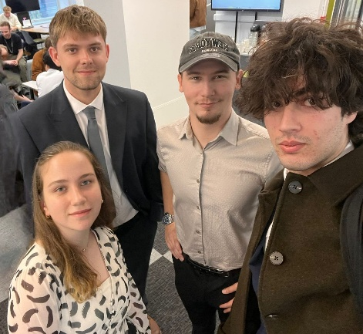
Okyanus Albas | Computer Science and Cyber Security
Tetiana Yarmola | Computer Science
Jamie Woodacre | Computer Science and Cyber Security
George Holden | Computer Science and Software Engineering

Main Client Bid
Dear Hai Van,
After attending your online meetings about your QTRobot Project, our team agreed it is something we are interested in developing. We already have relevant skills, such as app development experience, Linux experience and our team have various knowledge about other programming languages like Python, C, C++.
We want to gain knowledge on existing technologies like cloud computing and also facial recognition. We are excited to choose this project we hope to hear from you soon. Thank you for your time.
Secondary Client Bid
Dear Matthew Craven,
After attending your online meeting about your Gen AI for Visualising Evolutionary Algorithms our team is interested in developing this project. Our team has some experience in using python frameworks and we would be interested in developing skills about generative AI and its applications We hope to hear from you soon!
Thank you for your time.

Tertiary Client Bid
Dear Tomek,
After attending your online meeting about your Adaptive English Learning App with AI driven UI our team is interested in developing this project. We would be a good fit for this project because There are members within our team that are international that can bring different perspective.
Our team has some experience in variety of programming languages
We hope to hear from you soon!
Thank you for your time.

